Docker

* Docker is an open-source centralized platform designed to create, deploy and run applications.
* Docker uses container on the host O.S to run applications it allows applications to use the same linux kernel as a system on the host compute, rather than creating a whole virtual O.S.
* We can install Docker on any O.S but Docker engine runs natively on linux distribution
* Docker written in go language.
* Docker is a tool that performs os level virtualization, also known as Containerization.
* Before Docker, many users faces the problem that a particular code is running in the developer’s system but not in the users System.
* Docker was first release in March 2013, it is developed by Solomon hykes and Sebastion pahl.
* Docker is a set of platform as a service that uses O.S level virtualization whereas VMware uses Hardware Virtualization.

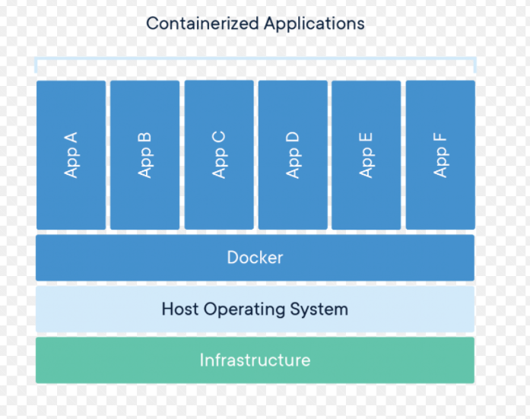

**Difference between virtual machines and containers**

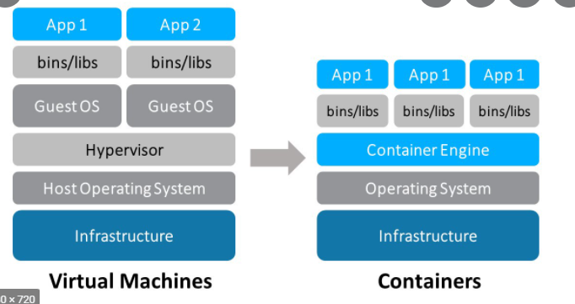

***Advantages of Docker***

* *No pre-allocation of Ram*
* *CI Efficiency -> Docker enables you to build a container image and use that same image across every step of the deployment process.*
* *Less Cost*
* *It can run on physical Hardware or Virtual hardware on cloud.*
* *You can reuse the image.*
* *It take very less time to create Containers.*

***Disadvantages of Docker***

* *Docker is not a good solution for application that requires rich GUI.*
* *Difficult to manage large amount of containers.*
* *Docker does not provide Cross – platform compatibility means if an application is designed to run in a Docker.*

*Container on windows, then it can’t run on Linux or vice-versa.*

* *Docker is suitable when the development O.S and testing O.S are same if the O.S is different, we should use Vm.*
* *No solution for data recovery and backup.*

***Architecture of Docker***

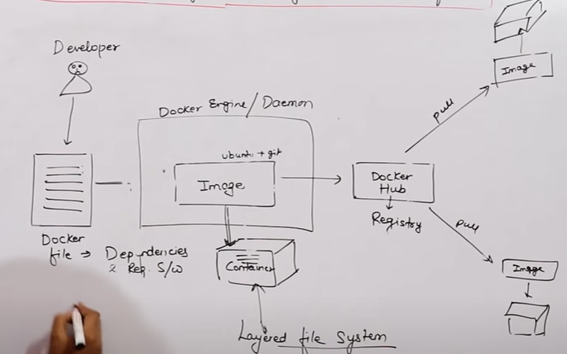

* *Container is a layer file system.*

***Docker is a Ecosystem***

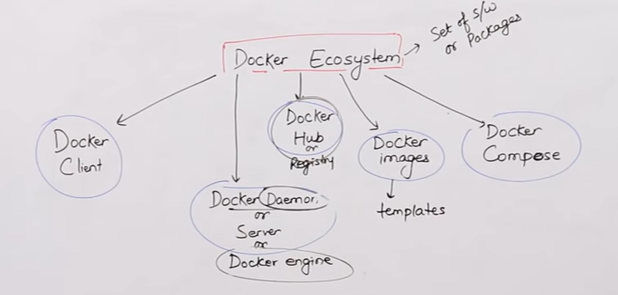

***COMPONENTS OF DOCKER***

***Docker Daemon =>***

* *Docker daemon runs on the host O.S.*
* *It is responsible for running containers to, manage Docker services.*
* *Docker Daemon can communicate with other daemons.*

***Docker Client =>***

* *Docker users can interact with Docker daemon through a Client. (like CLI)*

* *Docker client uses commands line and Rest API to communicate with the Docker daemon.*
* *When a client runs any server command on the Docker client terminal, the client terminal sends these Docker commands to the Docker daemon.*
* *It is possible for the Docker client to communicate with more than one daemon*

***Docker Host******=>***

* *Docker host is used to provide an environment to execute and run applications, It contains the docker daemon, images, containers, networks and storages.*

***Docker Hub/Registry***

* *Docker registry manages and stores the Docker images.*

* *There are two types of registries in the Docker.*

***1 =>******Public Registry*** *= Public registry is also called as Docker hub.*

***2 => Private Registry*** *= It is used to share the images within the enterprise or company employee.*

***Docker Images :-***

* *Docker image are the read only binary templates used to create docker containers.*

***Or***

***Single file with all dependencies and configuration required to run a program.***

***Ways to create an Images***

*1= Take image from Docker hub*

*2= Create image from Docker file.*

*3= Create image from existing Docker Containers*

***Docker Container***

* *Container hold the entire packages that is needed to run the application*

***Or***

*In other words, we can say that, the image is a template and the container is a copy of that template.*

* *Container is like a Virtual Machine, because containers helps you to run your application.*
* *Images becomes container when they run on Docker engines*

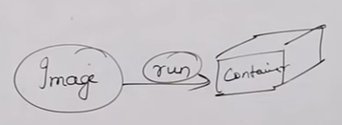

*------------------------------------------------------------------------*

* *We can’t do modify in image only container can modify your image.*



